**Dynamic feeding model development by the comparison of actual body weight values and existing models.**

1. **Feeding models (state of the art)**

Feeding models are of great importance for proper animal growth and consequently in livestock proper development. The aim of feeding models is to predict the dry matter intake (DMI) that must be provided to the animals to gain the optimum weight. Under this rationale, several factors are considered to achieve the best possible results in terms of result accuracy (exact amount of DMI). Currently, many approaches have been developed in the literature concerning prediction of the DMI for livestock, including cattle. The different approaches relay on the parameters that are chosen by each research work and are considered to have effect on the DMI value. However, it is observed that implementation of models in different locations and species also present differences. In the work of de Haas et al., (2012), the differences between the DMI, even in same species located in different regions has been highlighted [1]. A relevant good adjustment was observed in the application of existing models for DMI prediction in tropical regions for growing cattle [2], but still to improve the accuracy of prediction several factors should be considered such as environmental factors, diet variations etc. So, in any case, feeding models are more appropriate to be developed for each case separately and not applied in a more generic way. Some other reasons that the development of feeding models in cattle are not easy to be developed is the fact that data for such applications are not always available and properly organized [3]. Especially in beef or heifers obtaining the necessary data for such purposes is not always accesible as feeding is performed in groups and the parameters that relate to DMI and body weight (BW) are not measurable. Data obtained methods lead to the classification of DMI equations, in two big categories as referred by Tedeschi et al., (2003). The fist category includes every DMI equation that occurred using average DMI and BW data, which results in linear equations. When the data are obtained by experimental works where feeding trials are performed, the equations are usually non- linear equations [4]

In a model development research work concerning DMI of dairy cows the data obtained to create the database are automatically collected (DMI, milk production, BW etc) [5] as in most cases this livestock type is more controlled and orientated in each animal individually when it comes to modern facilities. For beef and heifers this is not an easy task to do, so models with actual data are not developed so easily in commercial applications. Similar management in heifers is conducted in research works where the feed amount is measured in a daily basis and is provided to each animal individually [6] in order to conclude in more solid results. One of the approaches, that has been used extensively as a basis for other research work for beef cattle, was performed by the National Resource Council. The parameters that have been considered were the Shrunk body weight (SBW) and the energy of feed intake (NEin). This model requires actual data (SBW) and theoretical data (NEin) which can be different according to gender and age [7]. In another model developed by Quigley (1986) the daily DMI related to the average daily gain (ADG), the BW and the Total digestible nutrients (TDN) [3]. Those feeding models are based in average data already acquired by actual projects, actual measurements that must be performed (ADG, BW etc) and of course data from the literature (NEin, TDN).

Several feeding models works for livestock and as consequence for cattle are based on non- linear equations. Many research works have been based in the cumulative distribution exponential function (Eq 1).

 (1)

The parameters a and b are defined based on each case and represent different factors. In DMI prediction this variable is usually the BW. However there also mixed models which include more variables such as neutral detergent fiber (NDF) or the temperature [3]. Following the same approach with non-linear based models Huuskonsen et al., (2013), developed a model which related the DMI with the body weight. This model could be improved when NDF and VTA where taken into account which are factors that are strongly connected with the dietary composition [8]. In the research work of C.A Bateki and U.Dickhoefer (2019), a semi mechanistic conceptual mathematical model was used to predict the voluntary DMI (VDMI) of growing cattle in regions with tropical or semi-tropical climatic conditions [9]. In this model the BW and dry matter digestibility we considered (DMD) to predict the VDMI.

The most important parameters that are considered necessary for DMI predictive models are the BW, the TDN, NEin and in some cases environmental conditions such as the temperature. Up to know the data concerning the above parameters are obtained with specific methods. Body weight is mostly defined by scaling [4] in a daily basis, while in some works it is also mentioned the manual measuring of the animals [10]. The body dimensions of the animals relate to body weight and there are several approaches to calculate the body weight via this method [11]. Rest of the factors such as TDN or NEin, can be obtained by databases or actual cases. These values depend on the type of feed and animal species.

During the last years the necessity of precision livestock feeding as part of precision livestock farming has been highlighted. Precision livestock feeding is referred to the covering of daily feeding needs of animals based on their exact needs both in terms of quantity and nutrient composition. These feeding models are using advanced mathematical tools which are different compared to the ones used in feeding models already developed in the previous years. As mentioned by Pomar et al., (2019), precision livestock feeding includes the application of modern acquiring data systems such as sensors, low cost cameras, audio- visual equipment for ongoing and real time observations concerning health, animal welfare and feeding behavior [12]. A.D Berckmans and J.M Aerts developed a methodology for controlling living organism’s bio response, a method which can be expanded in any type of livestock type including livestock [13]. This method can be proven useful for the development of algorithms concerning the DMI prediction. Machine learning methods has also been involved recently in feed intake prediction. These models are mostly based in data concerning the feeding behavior of the animals. In a research work by Davison et al., (2021), the variable considered were the weight intake in a daily basis, DM intake using an electric feeder. Beyond these data, feeding behavior information were calculated such as visit at the feeders, time spend at the feeder, feed consumed at the feeder etc [14]. The outcome of this research showed that simple prediction models presented higher R2 valuesthan regression and machine learning techniques. However, the errors of these models were relatively higher since individual feeding patterns were not captured. Although regression and machine learning techniques occurred to lower errors results concerning individual intakes, they didn’t present sufficient precision of the DMI prediction, so their use is currently limited mostly in research and not practical applications [14].

DMI prediction is of high importance for producers and the livestock industry as it leads to enhanced productivity and less production cost. Many approaches to estimate the DMI have been developed over the years. The approaches are different due to data acquisition, dynamic or static mathematical model, mechanistic or simplified models. Over the years new technologies has been included in the improvement of feeding models as, the most data and most parameters included in the DMI prediction equations the highest the accuracy in prediction. The challenge of DMI is nowadays concentrating in developing quantity and quality of feed for individual animals to succeed the best development growth rate.

# **Dynamic feeding model development method**

## **General description of the methodology**

Many feeding models have already been developed as mentioned in chapter 1. All mentioned feeding models are based on actual case studies and the equations of DMI estimation are the result of the actual measurements of each case study. One crucial matter is to evaluate whether these equations can be adapted in case studies of the same species (i.e Holstein heifers or beef heifers etc) which are in different regions, with different housing characteristics etc. The question here is how and in which grade other factors, which are not included in the equations, are affecting the equations in a way that they cannot implemented in other cases. To perform the evaluation of the feeding models, the steps described in Table 1 are required.

|  |  |  |
| --- | --- | --- |
| **Table 1**. Steps for the development of a dynamic feeding model | | |
| Step# | Description | Method |
| 1 | Find an actual case study with characteristics closer to the existing feeding models | All models are referred to a certain species and consider specific input data such as feeding characteristics, environmental conditions etc. The choice of the equation must include the factors that are considered of great importance for the producer |
| 2 | Find the body growth curves of the chosen models which show the BW evolution with time | For each of the equations chosen there is a relevant body growth curve that shows how the weight of the heifer changes per day |
| 3 | Feed the evaluation process with data concerning the daily weight gain and body weight of animals | It is important to have daily data of the body weight of the animals. The body weight data can be gained by scaling (real) or by estimation via camera monitoring of the animal dimensions and relevant equations connected with BW (estimation) |
| 4 | Prediction of DMI with the BW data that are taken by step 3 | Apply the BW values of the actual case study on the feeding model chosen to calculate the feeding ratio of the next day |
| 5 | Comparison of the actual BW with the theoretical based on the growth curves of step 2 | Comparison of the actual graph occurs by the BW values occur by step 3 and the theoretical curves of step 2 |
| 6 | Evaluation of the actual curve compared to the theoretical curve | In this step a double evaluation must be performed   1. Comparison with the theoretical curve (quantitative: comparison of values/ qualitative: curve form). Here it is evaluated whether the curve is close to the theoretical in terms of absolute values and as a curve form (inclination etc) 2. Producer goals: Estimate whether this model application is close to the producer goals (growth rates etc). This second evaluation will show if the implementation of a completely different feeding model must be applied |
| 7 | Evaluation of each animals’ behavior and herd in general | In this step the evaluation of step 5 is customized for each animal if data are available. So, it can be seen if an animal has some issue on feeding, body weight gain etc. This can be an alarm for the producer to separate the animal or put it in a different group. The comparison can be performed both for with the theoretical curve and average actual curve |
| 8 | Day by day feeding model adjustment | According to the BW occur for each animal and for the herd in general the DMI equation can be modified to achieve the curve form that has been decided in step 6 (Theoretical or producer’s goal) |
| 9 | Outcome | An updated DMI prediction equation orientated to the applied farm |

In the following chapter an example of how this method can be applied to an actual case study is presented.

## **2.2 Dynamic feeding model development method/ example 1**

The case study that will be examined concerns a dairy cattle heifer barn in the region of Lagadas Thessaloniki Greece. The barn is housing dairy heifers in boxes of 20 animals. The producer has mentioned the body weight of dairy heifers is the most important parameter before the heifers enter the reproduction period. The weight must reach averagely the 220 kg in 8 months and about 380-400kg in 13-14months. Low or fast rhythm of weight gain are not desirable by the producer as in the first case the heifer will not reach the proper weight in the period that it is predicted while in the second the most possible is to have a high fat percentage. Yet it is very important to schedule the DMI properly to reach the desirable periods in the proper time without overfeeding or waste of feed which has an impact on the farm in economic terms. Up to now the producer is feeding the heifers with a constant rate of DMI for specific periods of time. This approach is empirical and us mentioned it does lead to a uniformity of animal’s weight for a specific percentage of the herd (about 80%). The rest of the animals don’t reach the goal set by the producer and present a variance compared to the desirable goal. In the example it will be shown how the methodology presented in chapter could be applied in the examined barn.

**1st step:** The feeding model that will be selected must be a feeding model for Holstein heifers. The model that will be selected is the one presented by Hoffman et al, 2008 [3] and it is a non-linear equation for Holstein heifers (Εq.2)

DMI=15,36 x [1-e(-0.0022xBW)] (2)

The model was chosen as the producer for him mentioned that the BW is the crucial factor for DMI is the BW.

**2nd step:** The BW theoretical curve for the Holstein heifers is shown in graph 1.

**Graph 1**. Body weight of Holstein heifers [15]

**3rd step:** Start scaling or estimating body weight by any other method (camera, body dimensions etc)

**4th step:** Feed the DMI equation with the BW values of the barn

**5th step:** Comparison of the actual curve with the curve occurred by the actual values of BW and as a result DMI. An example is shown in Graph 2.

**Graph 2**. Body weight of Holstein heifers theoretical (grey) and actual (blue)

**6th step:** To evaluate the graph and how the proposed model fits to the case examined a double evaluation will be performed. The first has to do in how the result is close to the theoretical curve. To do so a quantitative and qualitative comparison of the curves will be performed. The qualitative comparison shows how close is the actual graph to the theoretical or optimum curve. So, there must be a comparison between the values of the weight axis point by point and define any possible differences. Next, it should be estimated if a change in DMI equation should be realized to make a displacement of the curve to be close to the values of the theoretical value. The qualitative comparison will have to check the form of the curve. This can be by checking the first derivative of the curve which shows the inclination and with the second derivative to get the curvature. Both comparisons are of high importance. The qualitative comparison will show if this DMI equation is leads to proper results for the specific herd and case study. If the curve form is far from the theoretical it means that another model should be chosen to be applied in the specific herd.

**7th step**: Repeat the evaluation of step 6 for each animal if data are available. That way it can be seen if some animals follow or not the trend of the curve or which of them contribute mostly to the curve form. That way an initial evaluation on which animals should be separated from the herd.

**8th step:** To proceed with this step, the acceptable rate of deviation of the theoretical curve must be defined. This means that some limits should be set to accept if the actual curve is close to the theoretical. This has to do mostly with the quantitative comparison as it must be defined which inclination or curvature is acceptable. If the results are within the range of limits that has been set a reformation of the DMI equation must be performed based on previous results to reach the inclination values of the BW curve that has been set as the goal for this case study. If the curve form is the acceptable, the qualitative comparison should be also utilized to reform the DMI equation to reach the absolute individual values of the BW curve. If the qualitative comparison led to an inclination or curvature value far from the ranges that has been set, the model chosen is not the proper one and another one should be chosen. It would be preferable if various models were running to see which fits the best.

**9th step:** After the reformation of the equation, a feeding model orientated only to the examined barn will have been established. This equation can be used with safety from the producer to consume the proper amounts of DMI and succeed the BW gain rates that are desirable

## **2.3 Dynamic feeding model development method- integration of more parameters**

In the previous example the feeding model is based on an exponential function with the variation of one parameter to reach the optimum results. As it can be seen in the literature other feeding models include other parameters such as NEM or TDN, while in some of them the temperature can change the amount of the DMI required for optimum weight gain. In this case the same approach can lead to a customized feeding model. In paragraphs 2.1 and 2.2 the data needed for the adjustment of the curve and equation should be available from previous operation periods. To describe this methodology equations (2) [7] and (5) [3] of already developed feeding models will be used.

DMI (kg/d) = {BW0.75 x [(0.2435 x NEM)- (0.0466 x NEM2)-0.1128}/NEM (2)

DMI variations when temperatures are beyond the thermal neutral zone are taken according to Equations (3) and (4).

Heat stress: temperatures Y>20° C, DMI x [1 - ((Y °C - 20) X 0.005922)] (3)

Cold stress: temperatures Y< 5° C, DMI x /[1- ((5 - Y° C) X 0.004644)] (4)

DMI, kg/d = 2.99 + (0.0144 × BW) + (−0.0029 × T) + (−0.041 × NDFdv) (5)

In the case of Equation (2), the parameters to be varied are the factors that are multiplied with the NEM or the exponent of the BW. Assuming that the most crucial factors are the one that is multiplied with the square of the NEM and the exponent (they have a more crucial impact on the result), they will be varied with the same rationale described in paragraph 2.2 to adjust the equation to the actual case. In both equations (2) and (5) the temperature parameter is included. As it can be seen in Equations (3) and (4) this parameter is included after the initial DMI has been calculated and a modified value of this parameter is the outcome of this. In the case of Equation (5) the temperature parameter is included in the initial calculations. In both equations (2) and (5) the values of NEM and NDFdv must be taken as data for the specific races from the literature and only the factors should be modified, while the variables should be the DMI, BW and T. Considering the literature according to growing steers and heifer calves the value of NEm is shown in Table 2.

|  |  |
| --- | --- |
| **Table 2.** NEm for growing steers and heifer calves | |
| Weight (kg) | NEm (Mcal) |
| 136 | 3,1 |
| 181 | 3,8 |
| 227 | 4,5 |
| 272 | 5,2 |
| 317,5 | 5,8 |

On the other hand, the NDFdv value is the neutral detergent fiber deviation. It actually counts most of the structural components in plant cells such as lignin, hemicellulose and cellulose but not contents as pectin [16]. Neutral detergent fiber has been evaluated for various types of feeds and it is expressed as a percentage of the DMI. If the feed is a variation of these type of ingredients the NDF must be calculated according to this variation. In Table 3 an evaluation of NDF is shown.

|  |  |
| --- | --- |
| **Table 3.** NDF evaluation for various type of feeds [17] | |
| Feed type | NDF (% DMI) |
| Timothy hay | 65,5 |
| Wheat straw | 83,8 |
| Alfalfa hay | 46,8 |
| Wheat bran/ hard red | 48,2 |
| Corn Silage | 51,5 |
| Green peas | 15,2 |

So, to proceed with the adjustment of these models the producer must upload to the platform the type of the feed that he is using. That way the NDF percentage will be chosen by Table 3. The NEm value will be chosen according to the weight of the animals. So, as the animal is growing the NEm will change each time the animal’s weight moves to the next category the NEm will change. It is obvious that for the monitoring of the barn if the farmer is uploading data frequently the equation adjustment will be more accurate and closer to the situation of the period the animals are examined. In paragraph 2.4 an example of how the farmer should proceed with data uploading is described both in the initial phase (feeding model adjustment) and during the monitoring period. The steps 1-4 are actually the same.

**2.4 Dynamic feeding model development method- integration of more parameters/ example 2**

**1st step:** The feeding model that will be selected is the one that is described in eq.2. In this equation the parameters that are varied are the DMI and BW, which are the ones that must be defined. This equation includes the NEm parameter, and it is further modified with the temperature. If the user wants to proceed with this equation, he must initially upload data from a previous period including

DMI (kg/d) = {BW0.75 x [(0.2435 x NEM)- (0.0466 x NEM2)-0.1128}/NEM (2)

DMI variations when temperatures are beyond the thermal neutral zone are taken according to Equations (3) and (4).

Heat stress: temperatures Y>20° C, DMI x [1 - ((Y °C - 20) X 0.005922)] (3)

Cold stress: temperatures Y< 5° C, DMI x /[1- ((5 - Y° C) X 0.004644)] (4)

**2nd step:** The BW theoretical curve for the Holstein heifers is shown in graph 3.

**Graph 3**. Body weight of Holstein heifers [15]

**3rd step:** Start scaling or estimating body weight by any other method (camera, body dimensions etc)

**4th step:** Feed the DMI equation with the BW values of the barn

**5th step:** Comparison of the actual curve with the curve occurred by the actual values of BW and as a result DMI. An example is shown in Graph 4.

**Graph 4**. Body weight of Holstein heifers theoretical (grey) and actual (blue)

**6th step:** To evaluate the graph and how the proposed model fits to the case examined a double evaluation will be performed. The first has to do in how the result is close to the theoretical curve. To do so a quantitative and qualitative comparison of the curves will be performed. The qualitative comparison shows how close is the actual graph to the theoretical or optimum curve. So, there must be a comparison between the values of the weight axis point by point and define any possible differences. Next, it should be estimated if a change in DMI equation should be realized to make a displacement of the curve to be close to the values of the theoretical value. The qualitative comparison will have to check the form of the curve. This can be by checking the first derivative of the curve which shows the inclination and with the second derivative to get the curvature. Both comparisons are of high importance. The qualitative comparison will show if this DMI equation is leads to proper results for the specific herd and case study. If the curve form is far from the theoretical it means that another model should be chosen to be applied in the specific herd. In the case of the used equation, this evaluation should follow a specific roadmap. This way it can be found which factor affects the form of the curve, more drastically. As a first approach the 2 factors that will vary to check the adjustment of the curve to the optimum one is the exponent (0,75) and the factor 0,0422 multiplied with NEm2. The values of NEm are taken according to Table 2 depend on the weight. After the outcome of the BW or DMI to be fed the extra adjustment with the temperature can be performed.

**7th step**: Repeat the evaluation of step 6 for each animal if data are available. That way it can be seen if some animals follow or not the trend of the curve or which of them contribute mostly to the curve form. That way an initial evaluation on which animals should be separated from the herd.

**8th step:** To proceed with this step, the acceptable rate of deviation of the theoretical curve must be defined. This means that some limits should be set to accept if the actual curve is close to the theoretical. This must do mostly with the quantitative comparison as it must be defined which inclination or curvature is acceptable. If the results are within the range of limits that has been set a reformation of the DMI equation must be performed based on previous results to reach the inclination values of the BW curve that has been set as the goal for this case study. If the curve form is the acceptable, the qualitative comparison should be also utilized to reform the DMI equation to reach the absolute individual values of the BW curve. If the qualitative comparison led to an inclination or curvature value far from the ranges that has been set, the model chosen is not the proper one and another one should be chosen. It would be preferable if various models were running to see which fits the best.

**9th step:** After the reformation of the equation, a feeding model orientated only to the examined barn will have been established. This equation can be used with safety from the producer to consume the proper amounts of DMI and succeed the BW gain rates that are desirable.

**10th step:** In phase 2 of the feeding model development other factors of the equation can be modified by keeping constant the ones that were initially modified. This is since it is not clear which factor can affect more efficiently the curve form. If a more accurate equation demanded all factors must be modified and check the result. However, if from the first approach a satisfactory result occurs it can be considered acceptable.

**2.5 Process optimization**

In both approaches (Example 1 and Example 2), it will be useful if the farmer has data from a previous period or collect data before using the platform. That way the actual data can be initially uploaded to the platform to create a first equation approach and optimization. If this is not possible, then during the first period of operation the system won’t be able to perform the monitoring of the herd, but it will build this first form of the equation. In the case of the second equation (NEm and Temperature included), the capability of following the NEm value according to the actual weight is also an option, in contrast with the use of average values as the ones in Table 2. Also, for the NDFdv, the actual percentage can be defined by equations or via the above estimations if the percentage of each type of feed used in the DMI is known.

Despite the above, it should always be considered that the platform should demand the less actions by the farmer and do most of the job by itself. So it is suggested to keep the process in a relatively simple function level with the less possible information uploaded by the user.

1. **Feeding model tool on the platform- user requirements interaction**

The above methodology can be implemented to a software-platform where farmers can use for creating their own feeding model. To do so the farmers should feed the model with data concerning the weight gain of their farms when following one of the feeding models proposed by the platform- software. So, part of the herd should be the pilot for a specific period. The software will estimate whether the model chosen is the proper one or it should be replaced with another from the ones included in its’ database. If the model is the right one the software will perform the reformation of the DMI equation. In Figures 1 and 2 the rationale of how the utilization of the data can be used by the farmer’s network through the ATLAS platform is highlighted. In Figure 1 the method of how the customized feeding model is developed is visualized. In this case the farmers must upload data from previous years in an initial phase. After this, the most updated the platform is kept by the farmer with data of the current period the most reliable the adjustment will. Moreover, additional information concerning possible issues of the herd will be more precise. In Figure 2 some of the potential expansions of the system’s capability are also highlighted. Some of the most important are the creation of a library with developed feeding models and the options for the user concerning the limits set etc.

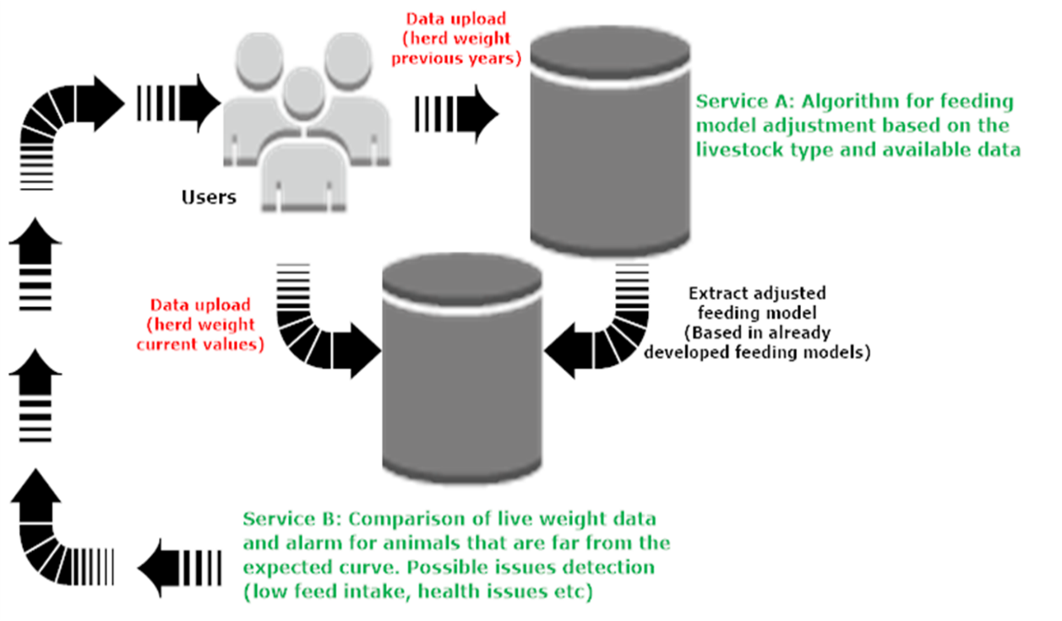

**Figure 1.**  Feeding model adjustment based on existing feeding models-user interaction

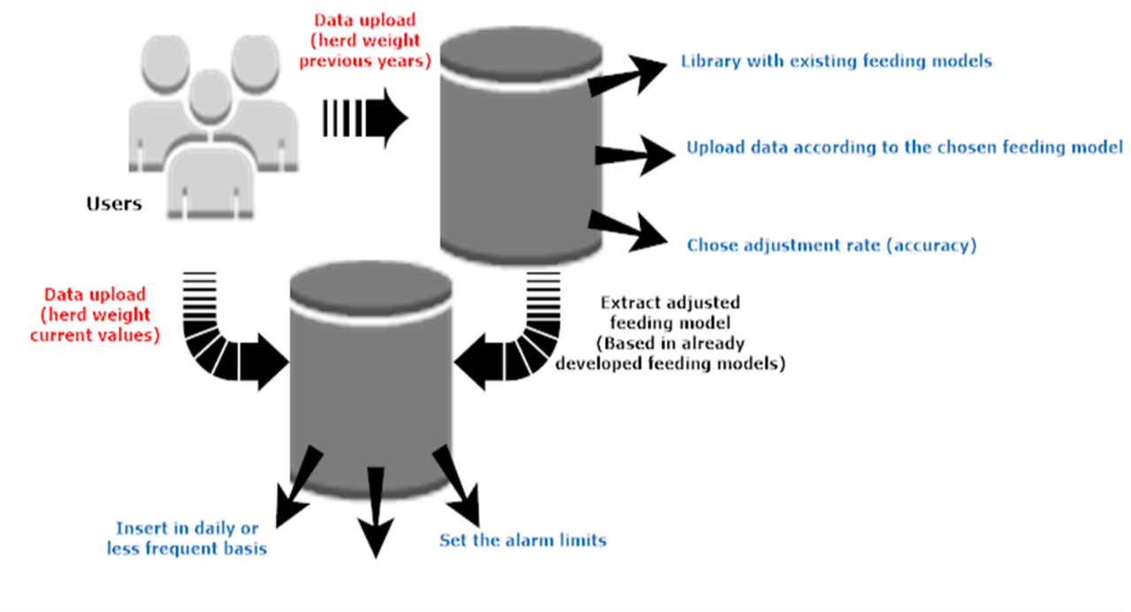

**Figure 2.** Feeding model adjustment based on existing feeding models-system capability

After the DMI equation receives its final form, the farmer can use the tool. This tool will perform a comparison between the theoretical curve for the case study it occurred by the pilot case. The basic information that will be provided will be if the animals weight values are on or close to the reformed growth curve. If not, an alarm will be sent to the producer to take actions (check for illness, check for weak animal, overweight animal etc). The most the data the more accurate the equation will be over the years, and it will be more and more orientated to the examined case study. An example of how the interface of this tool can be is shown in Figure 3.

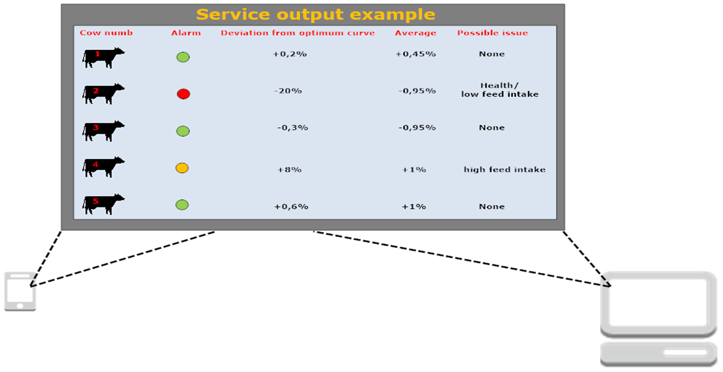

**Figure 3.** Service example based on the dynamic feeding model development

Another function- operation of the service could be the creation of a data base which will give the option to the farmers to chose modified feeding models already developed for current users. This could be very useful as the farmers could choose models which are closest to the climatic conditions of their and animals’ races closest to their races.

**References**

[1] Y. de Haas, M.P. Calus, R.F. Veerkamp, E. Wall, M.P. Coffey, H.D. Daetwyler, B.J. Hayes, J.E. Pryce, Improved accuracy of genomic prediction for dry matter intake of dairy cattle from combined European and Australian data sets, Journal of dairy science, 95 (10) (2012) 6103-6112.

[2] A.S. Oliveira, V.B. Ferreira, Prediction of intake in growing dairy heifers under tropical conditions, Journal of dairy science, 99 (2) (2016) 1103-1110.

[3] P.C. Hoffman, K.A. Weigel, R.M. Wernberg, Evaluation of equations to predict dry matter intake of dairy heifers, Journal of dairy science, 91 (9) (2008) 3699-3709.

[4] Luis O. Tedeschi, Danny G. Fox, M.J. Baker, The Cornell Value Discovery System Model-Model documentation, in, Department of Animal Science- Cornell University,, USA, 2003.

[5] S. Liang, C. Wu, W. Peng, J.X. Liu, H.Z. Sun, Predicting Daily Dry Matter Intake Using Feed Intake of First Two Hours after Feeding in Mid and Late Lactation Dairy Cows with Fed Ration Three Times per Day, Animals : an open access journal from MDPI, 11 (1) (2021).

[6] Y. Akbaş, A. Alçiçek, A. Önenç, M. Güngör, Growth curve analysis for body weight and dry matter intake in Friesian, Limousin x Friesian and Piemontese x Friesian cattle, Archives Animal Breeding, 49 (4) (2006) 329-339.

[7] National Research Council, Nutrient Requirements of Beef Cattle, 7th ed., The National Academies Press., Washington DC, 2000.

[8] A. Huuskonen, P. Huhtanen, E. Joki-Tokola, The development of a model to predict feed intake by growing cattle, Livestock Science, 158 (1-3) (2013) 74-83.

[9] C.A. Bateki, U. Dickhoefer, Predicting dry matter intake using conceptual models for cattle kept under tropical and subtropical conditions1, Journal of animal science, 97 (9) (2019) 3727-3740.

[10] M. Williams, R. Prendiville, K. O’Sullivan, S. McCabe, E. Kennedy, M. Liddane, F. Buckley, Developing and validating a model to predict the dry matter intake of grazing lactating beef cows, Animal : an international journal of animal bioscience, 13 (11) (2019) 2639-2649.

[11] K. Wangchuk, J. Wangdi, M. Mindu, Comparison and reliability of techniques to estimate live cattle body weight, Journal of Applied Animal Research, 46 (1) (2017) 349-352.

[12] C.Pomar, J. van Milgen, A.Remus, Precision livestock feeding, principle and practice-Poultry and pig nutrition,, in, Wageningen Academic Publishers,, Netherlands, 2019.

[13] Berckmans D.A, Aerts J-M, Method and system for controlling bioresponse of living organisms, in: E.P. Office (Ed.), EU, 2005.

[14] C. Davison, J.M. Bowen, C. Michie, J.A. Rooke, N. Jonsson, I. Andonovic, C. Tachtatzis, M. Gilroy, C.A. Duthie, Predicting feed intake using modelling based on feeding behaviour in finishing beef steers, Animal : an international journal of animal bioscience, 15 (7) (2021) 100231.

[15] Jones.C.M, Heinrichs.J, Growth Charts for Dairy Heifers, in: College of Agricultural Sciences, The Pennsylvania State University,, USA, 2017.

[16] Wickepedia, Neutral detergent fiber, (2021).

[17] P. J. Van soest, J. B. Robertson, B. A. Lewis, Methods for Dietary Fiber, Neutral Detergent Fiber, and Nonstarch Polysaccharides in Relation to Animal Nutrition, Journal of dairy science, 74 (1991) 3583-3597.